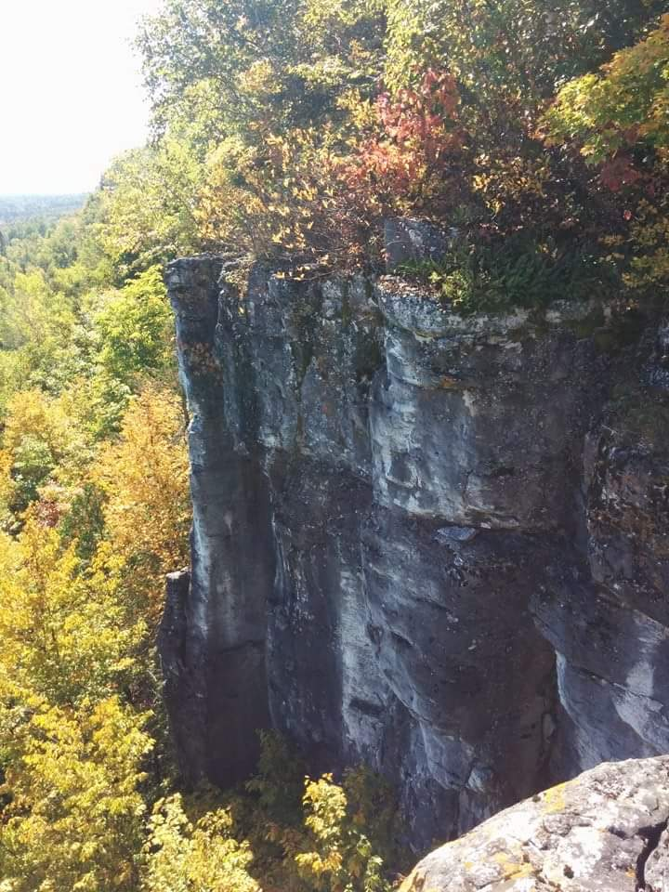
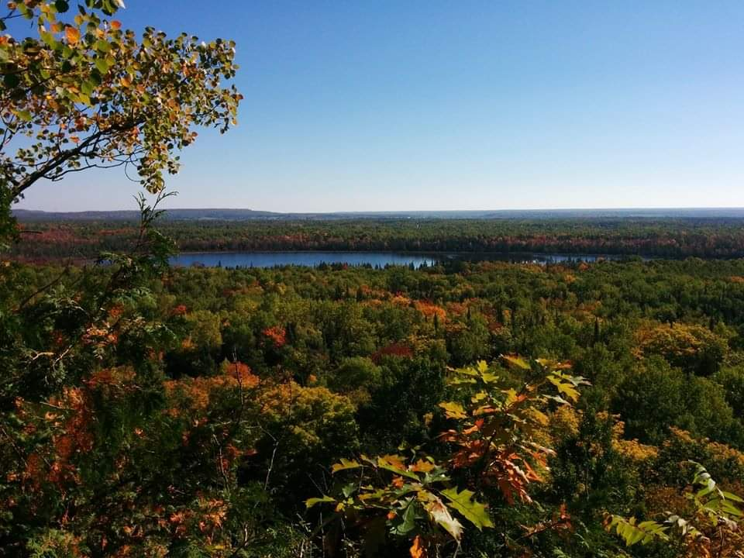

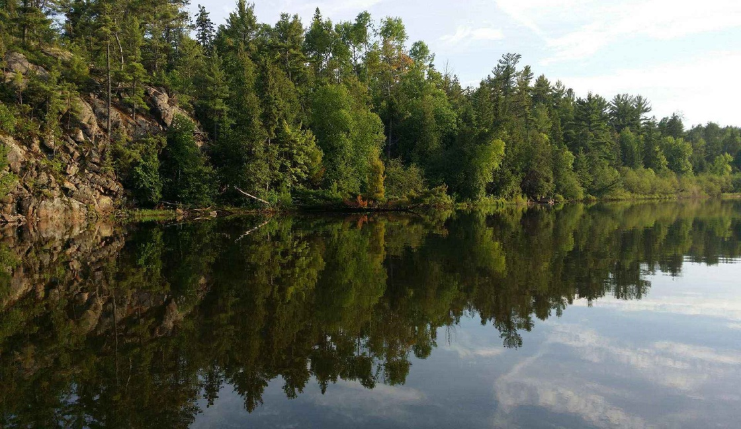
How to Partner with Indigenous Communities and Organizations to Conduct Technology Development Research

A guide for working with communities to develop and adapt technology to age in place

Developed by Aging Technologies for Indigenous Communities in Ontario (ATICON, WP1.1b)

Contributors

Dr. Kristen Jacklin, PhD, Professor, Memory Keepers Medical Discovery Team, University of Minnesota Medical School, Duluth campus; Professor, Human Sciences Division, Northern Ontario School of Medicine

Dr. Melissa Blind, PhD, Memory Keepers Medical Discovery Team, University of Minnesota Medical School, Duluth campus

Dr. Andrine M. Lemieux, PhD, Memory Keepers Medical Discovery Team, University of Minnesota Medical School, Duluth campus

Karen Pitawanakwat, RN, Naandwechige-Gamig Wikwemikong Health Centre

Melinda Dertinger, MA, Memory Keepers Medical Discovery Team, University of Minnesota Medical School, Duluth campus

Acknowledgments

This work was supported by AGEWELL NCE (AW CRP 2015-WP1.1b) and the Memory Keepers Medical Discovery Team, University of Minnesota Medical School, Duluth. We would like to thank all the individuals and groups who contributed to the creation of this resource. This work could not be completed without our community partners, the members of our Community Advisory Council and all individuals who participated in our focus groups and interviews.

Our community partners include:

Naandwechige-Gamig Wikwemikong Health Centre
Mnaamodzawin Health Services
Noojmowin Teg Health Centre
M’Chigeeng Health Services
Wiikwemkoong Unceded Territory
M’Chigeeng First Nation
Sheguiandah First Nation
Sheshegwaning First Nation
Wauwauskinga First Nation
Zhiibaahaasing First Nation
Aundeck Omni Kaning First Nation

The Community Advisory Council include:

Rosella Kinoshameg
Edward Osawamick
Roselinda Peltier
Joe Peltier
Evelyn Roy
Marion McGregor
Rose Shawanda
Monica Pheasant
Jules Osawamick
Roseanne Debassige
Bonita Bebamash
Bill Antoine
Jean McGregor-Andrews
Late Thecla Pheasant
Late Isaac Pitawanakwat

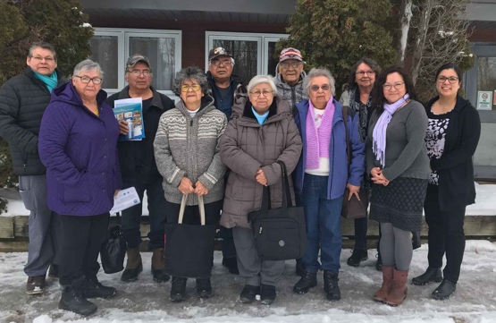
Back row L-R: Bonita Bebamash, Joe Peltier, Edward Osawamick, Bill Antoine, Roseanne Debassige, Rhonda Trudeau.
Front row L-R: Roselinda Peltier, Evelyn Roy, Rosella Kinoshameg, Marion McGregor, Karen Pitawanakwat.
Picture taken January 15, 2020 Wikwemikong Health Centre.

We would like to thank Jessica Chiovitte, Research Associate, Memory Keepers Medical Discovery Team, University of Minnesota Medical School, Duluth campus for her administrative contributions. We would also like to thank former Research Coordinator, Louise Jones, for all of her contributions to this work. Miigwetch!

Contents

Contributors 2
Acknowledgments 2
Contents 4
Introduction 5
Indigenous Health 5
Culturally Safe Approaches 5
Need for Meaningful Engagement and Collaboration 5
How to Develop Technologies with Communities 6
An Example: Manitoulin Island & Community Based Participatory Action Research (CBPAR) 9
Our Goals 9
Our Team 9
Methods 10
Case Study – Application of the Value of CBPAR 11
Recommendations 12
Resources 13
References 14

Introduction

Indigenous Health
With the increasing aging global population, there is growing concern from health and social service providers that chronic conditions will threaten the ability of older adults to age in place (Alzheimer Society of Canada, 2010). Indigenous communities globally experience significantly higher rates of chronic conditions that require health and social services, yet they often lack accessibility to services that support aging in place in rural and remote locations (Health Canada, 2009; Maar et al., 2015). Indigenous adults and their families often prefer family caregiving models, as they are culturally grounded and more comprehensive than those found in the general population (Jacklin, Pace, & Warry, 2015). Technology can work with family caregiving models to support aging in place, but technologies brought to Indigenous communities by outsiders could be viewed with suspicion and as tools of on-going colonization. The capacity for Indigenous populations to age in place is disproportionately affected by colonial policies and practices, and research involving Indigenous populations must address the lasting effects of colonialism in the researcher-community relationship by working collaboratively and utilizing culturally safe approaches. In other words, solutions should be developed with, rather than for Indigenous communities. Embracing Indigenous Ways of Knowing and Indigenous knowledge are crucial in developing culturally safe and effective solutions.

Culturally Safe Approaches
Developing technologies with Indigenous communities allows for the creation of useful and relevant products and decolonizes the process (Jones, Jacklin, & O’Connell, 2017). Utilizing culturally safe approaches means that the research methods employed must consider and acknowledge the distinct cultural experiences and needs of particular communities with which organizations like technology companies are working (Wilson & Neville, 2009). A community-based participatory action research (CBPAR) design should be adopted to accomplish the goal of conducting culturally safe technology research and development. A CBPAR design involves users, caregivers, health professionals, and Elders or Traditional Knowledge Keepers throughout the entire research process – from product development to evaluation (Jones, Jacklin, & O’Connell, 2017). It is beneficial to utilize a two-eyed seeing lens in this type of research. Two-eyed seeing is a methodology in which western and Indigenous perspectives are held equally and used with the goal of improving health and wellbeing for the next seven generations (Marshall, Marshall, & Bartlett, 2015).

Need for Meaningful Engagement and Collaboration
Few published studies have examined assistive technology use, development, or adaptation in Indigenous populations globally. Even fewer studies detail the importance of meaningful engagement and collaboration with Indigenous communities during this process. Most of these studies have taken place in Canada, Australia, and the U.S., indicating a need for similar research in other areas globally (Jones, Jacklin, & O’Connell, 2017). Although there is relatively little research on this topic, Indigenous communities can benefit greatly from innovative technology to support aging in place and are generally eager to partner in research if they are meaningfully engaged in all phases of the project (Jones, Jacklin, & O’Connell, 2017). Previous research teams have found greatest success in terms of product acceptance and uptake when they collaborated with Indigenous communities for technology development (Jones, Jacklin, & O’Connell, 2017). To help advance the field and find equitable solutions that allow Indigenous individuals to age in place, we have created this guide for researchers and technology companies who wish to partner with Indigenous communities in technology development and adaptation research.

How to Develop Technologies with Communities
At their core, collaborative and culturally safe research and development approaches are about building and maintaining trust – a continuous process that takes time and effort. There are many important steps to complete and connections to make before you can distribute your product to the community. Throughout the process, it is crucial to acknowledge and respect the experiences of the community, listen openly to community members, understand and utilize the expertise of both the academic/industry and community partners, and be upfront and sincere about expectations and intentions. Here we detail a pathway of forming these meaningful partnerships to develop technology with communities. Note that the pathway to collaboration is not linear and some stages will be repeated.

Figure 1. Pathway to Collaborative and Culturally Safe Research and Development (cite infographic).

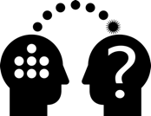
- Community identifies a priority
The first step of collaborative research is to ask and listen to what the community needs – without assuming you know the answers or solutions. You should be prepared to learn as much as you contribute. Members of a community first identify a need and express interest in forming a partnership to resolve that need. Ideally, the community should reach out to the research partners first, but opportunities for collaboration may be established through meaningful outreach and engagement. For example, developers can reach out to and build relationships with community champions who can then approach the community to identify needs. Networking opportunities can be found by regularly attending events sponsored by relevant organizations, such as Indigenous health conferences, Friendship Centers, and Aboriginal Health Access Centers. It can take time to build these meaningful relationships, develop trust, and form a collaboration.

- Start the conversation early
Start communicating with community members, local champions, partners, and stakeholders early to begin discussing plans. You should discuss broad goals, funding opportunities, feasibility, community concerns, community access and connectivity, and how the mission and values of your organization align with the needs of the community, to name a few topics. Your expectations and intentions should be clear, honest, and sincere. Discuss how a partnership might benefit the participants, community, and society as a whole.
Keep in mind: When engaging in discussions, you should include community voices from all age groups – from youths to Elders – in order to better understand community dynamics and the community as a whole.

- Seek appropriate community approvals to support the research and your new partner(s)
Ask about the community approval process, including who you need to be reporting to, and how often. If there is a local research ethics board or committee, find out what you need to do to successfully complete the application.

- Establish a local community health researcher
In order to equitably involve each side of the partnership in the research process, it is important to ask the community leadership, or person you will be reporting to, about the process for hiring a local community researcher. The local community researcher (or researchers) will be involved in design, data collection, and interpretation and dissemination of findings. A local community researcher can also provide knowledge of their community and engage with participants who may be distrustful of western research methods.
- Work with the community researcher and community partner organization to establish an Advisory Group
Ask the community researcher(s) to identify and suggest members of the community that should be invited to join an Advisory Group. The Advisory Group will be made up of a diverse group of respected community partners who will guide the research process.
Members may include, but are not limited to youth, Elders, health care staff, formal and informal caregivers and natural helpers, and individuals representing traditional cultural backgrounds and / or language speakers. Members should include a mix of both men and women. Recruit people who can guide the work and ensure Indigenous Ways of Knowing and knowledge are woven into the project.

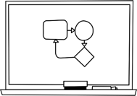
- Collaboratively establish a governance structure
Discuss how you will all work together and make decisions. Establish contingency plans and communication networks. A research agreement is necessary to assist with clarifying roles, responsibilities, reporting structures, and licensing or intellectual property rights.
- Collaboratively plan the project
Discuss the project goals, methodology, timelines, dissemination of findings, etc. Your plans will likely evolve as you communicate with and get feedback from the Advisory Group. Be open to new ideas and feedback.
Keep in Mind: Feedback may include new and unexpected ideas. It is important to actively listen to and ask open-ended questions to allow for a more in-depth conversation. These steps are all a part of the relationship building process and will ultimately add value to the overall project.

- Create an initial prototype
Design a prototype that incorporates the needs of the community, the requests of the Advisory Group, and the capabilities of your company.
- Take the prototype back to the Advisory Group for feedback
Present the prototype to the Advisory group for feedback to ensure that Indigenous Ways of Knowing and knowledge are woven into the final product.
- Revise the prototype based on feedback
Negotiate and incorporate feedback from the Advisory Group to re-design the product based on their requests (sometimes not all feedback is feasible). You may have to repeat this step a few times as you collaborate with the Advisory Group to create a product that meets everyone’s needs and capabilities.

- Seek approval to release the product
After you have adequately addressed all feedback from the Advisory Group, ask them to allow you to distribute the product to community members for evaluation and how to do so. They may have requests for who you distribute the product to and how it is distributed.

- Release the final product and adjust as needed
Provide the product to community members for evaluation. Make adjustments to the product as needed based on their feedback. Community and Advisory Group members should be acknowledged and involved in interpreting the results of the evaluation and publishing any evaluation reports or scientific manuscripts.

- Collaboratively integrate the tool into the community
Work with the Advisory Group to create a plan for integrating the final product into the community. Be sure to share results with all who were involved and/or will benefit from the findings of the research project: participants, community members, Advisory Group members, stakeholders, relevant organizations, and local champions identified by the community, to name a few. Continually follow-up with community and Advisory Group members regarding the product.

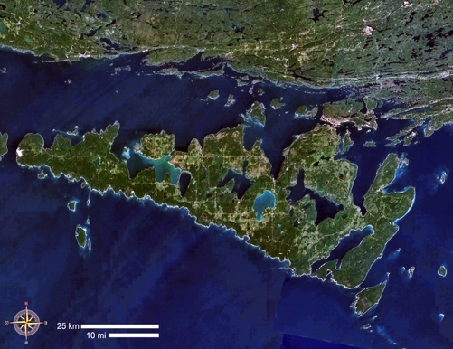
An Example: Manitoulin Island & Community Based Participatory Action Research (CBPAR)
Manitoulin Island is a large fresh water island located in northern Ontario, Canada and is home to seven First Nations communities. The island is made up of several distinct geographical locations, with many of the First Nations communities located in rural and remote areas.

Our Goals
Using the methods outlined above, we work closely with First Nation communities on Manitoulin Island to assess unmet assistive technology needs that support aging in place among rural and remote Indigenous communities. At the time of our research, we found few published studies on assistive technology use, development, or adaptation in Indigenous populations globally, particularly studies concerning specific diseases or older Indigenous adults (Jones, Jacklin, & O’Connell, 2017). We partnered with AGE-WELL NCE to address this gap in the literature and identify opportunities for innovation, with the ultimate goal of creating resources that could assist researchers and technology developers in working with Indigenous communities to develop culturally safe aging technologies.

Our Team
Our academic research team has been working with First Nation communities on Manitoulin Island for over 20 years. We have partnered with Indigenous communities to conduct several qualitative studies and gain rich, meaningful insight into health disparities faced by this population. Members of the team include academic researchers and Indigenous community partners. The community-based researcher is an Anishinaabe registered nurse, who has over 30 years of nursing experience and 14 years of research experience. Core research team members include:

- Dr. Kristen Jacklin
  - Primary Investigator, anthropologist, and an internationally recognized expert on cultural understandings of Indigenous dementia
- Dr. Wayne Warry
  - Co-Investigator, anthropologist, and has conducted extensive research on healthcare delivery in rural and remote areas
- Dr. Melissa Blind
  - Senior Research Associate
- Karen Pitawanakwat
  - Community Researcher

All of our work is guided by a local Indigenous Community Advisory Council comprised of older adults, health care providers, and caregivers from all seven First Nations communities on the Island. The Community Advisory Council members include:
- Marion McGregor
- Rose Shawanda
- Monica Pheasant
- Jules Osawamick
- Roseanne Debassige
- Late Thecla Pheasant
- Late Isaac Pitawanakwat

- Rosella Kinoshameg
- Edward Osawamick
- Roselinda Peltier
- Joe Peltier
- Evelyn Roy
- Bonita Bebamash
- Bill Antoine
- Jean McGregor-Andrews

In addition to our academic and community partners, we partnered with AGE-WELL NCE Inc. (Aging Gracefully across Environments to Ensure Well-being, Engagement and Long Life National Centre of Excellence), a five year federally funded initiative with the aim of helping older adults maintain independence, improve quality of life, and enhance social participation through technology. The Aging Technologies for Indigenous Communities in Ontario (ATICON, WP1.1b) team works closely with First Nations communities of Manitoulin Island. Our work aims to address how older Indigenous adults with dementia can be supported through technology to age in place. Our research focus responds to the growing recognition of inequitable access to health care and supportive technologies experienced by Indigenous peoples and the need for community driven, culturally safe approaches to technology development.

Methods
We used a two-eyed seeing approach for this project, equitably including Indigenous and western knowledge using CBPAR methods. As such, data collection methods evolved over the course of the project. Our work was conducted with and guided by a local Community Advisory Council, mentioned above. A community-based researcher, with assistance from the research team conducted focus groups and interviews and was involved in all aspects of the research process and data analysis. From April to August, 2016, we conducted four focus groups with older adults, health care providers, family caregivers, and natural helpers in four geographically distinct regions of the Island. Focus group participants were identified through community health services and Advisory Group connections. We asked participants about healthcare needs of older Indigenous adults and technologies that would support aging in place. In August, 2017, we followed up with an older adult from each focus group to conduct in-depth interviews with them, their families, and their caregivers using case study methods. In the interviews, we asked participants several open-ended questions about their life, health, aging, and exposure to and comfort with healthcare technologies. We used thematic analysis to identify key themes. The Community Advisory Council helped interpret the results and reviewed all presentations and publications generated from the project.

ATICON developed instructive case studies incorporating the results from the focus groups and individual in-depth interviews. The short case below provides a snapshot of the health complexities older Indigenous adults may face. We highlight here how the case study exemplifies themes identified through the use of CBPAR and how it might impact a technology development leader’s decision making or planning. Lessons or messages to the technology development team are identified in purple italics.

Case Study – Application of the Value of CBPAR
This story is about “Edna” (not her real name). Edna is an active older woman in her early 70s, who lives alone. She lives in a small remote First Nation community that has a population of under 100 people.

Edna has type 2 diabetes, osteoarthritis, and is a cancer survivor, who’s been in remission for the last 10 years. She has been a strong advocate for her own health over the years and has often had to work with the community health representative and her family physician to get coverage for travel to specialist appointments, as well as access to medical supplies and care. Recently, Edna has started having a little bit of trouble with her memory, but she has not discussed this with her family physician, nor has she mentioned this to her family.

Edna is an older First Nation adult in poor health who live in a remote location. Understanding logistics and demonstrating respect to cultural differences in research ethics will impact how you are perceived by the community leaders. Learning this requires you to complete the first 6 steps depicted in Pathway to Collaborative and Culturally Safe Research and Development (Figure 1). These first 6 steps may take you months or even a year to accomplish, but they are absolutely critical before you or your research team ever meet Edna. Each Indigenous community differs in how the Pathway will play out and what you have to learn about doing your research in a culturally respectful way. This can only happen through honest engagement with the community and careful following of the Pathway outlined above.

The community has limited health services available for residents. Cellular service became available in the community in 2016, but there are still dead zones in many areas of the island. For services in the community, a personal support worker (PSW) visits Edna during the week to help with activities of daily living and another person helps Edna with light housekeeping on a weekly basis. Edna also sees the foot care nurse that visits the community once a month. Physician services come to the community twice a month.

The remote location of this community means that driving is the only method of transportation, as there are not taxis, public transit, or commercial bus services. Edna has a reliable car and loves driving. She often provides rides to others in the community to get groceries, as well as access programs and services that are not available in the community. If Edna needs to see her family physician outside of the community clinic hours, she must drive approximately 45 minutes (58 km) to Gore Bay, ON. This is also where the nearest grocery store, laundromat, and pharmacy are.

The last 2 paragraphs provide a technology developer with clues to cultural strengths (natural helpers) as well as significant barriers (limited health care resources, long distance travel limited travel options once driving is no longer possible, late introduction to digital infrastructure). A tuned in technology leader will question why resources and infrastructure are so scarce. The community will likely describe a long history of colonial practices and policies that have created, or continue to facilitate, these health care barriers. Aging in place for Edna is clearly different than a similarly aged peer living in downtown Toronto. How might your products address and disrupt these or other barriers? Where can you think creatively and collaboratively to address the priorities that the community identifies for you? Remember, what you see as a priority is coloured by your own age, ethnicity, and experience with rural or remote life. You may be surprised by how the community prioritizes its needs. This is a good time for you to reflect on your own biases. What assumptions came to your mind about community needs? How do you feel about participating in partnership research that involves addressing social exclusion and disparities?

The two hospitals on the island are further away, taking approximately 90 minutes to drive to from the community. On one occasion, Edna fell and needed an ambulance. The local community team needed to first assess Edna and determine that an ambulance was necessary. This initial assessment took over 30 minutes. It then took the ambulance an hour and a half to arrive and conduct their own assessment, followed by an hour and a half to reach the emergency department from where she lives.

From one fall Edna learned the importance of creating a habitual routine to prevent this event from happening again. Transportation costs of the care she needed to recover was not covered because it was not more than 100km or more in distance (a medical travel subsidy can be obtained if the roundtrip travel is greater than 100km).

Unintentional physical injuries have limited Edna in participating in social activities such as canning. She is very resourceful in communicating with her community for supports she needs like care after a fall, meals, loss of electrical power, and to continue to community with the different generations in her community via Facebook.

Edna prefers to treat pain, gastric upset, and inflammation with natural medicines. She believes elders are not fully embracing their wisdom because of many underlying traumas that remain unresolved as they age. For example, unresolved grief comes from not being able to practice one’s culture or language, Indian Residential Schools, child apprehensions stemming from “the 60’s scoop”, along with experiences of individual and systemic racism and discrimination. Edna feels that by not acknowledging or addressing these underlying traumas, these experiences may continue to bother them as they age and this is what gets them sick. She advises all young elders to exercise to combat this stressor, which also benefits the loss of muscle mass as we age. She admits she didn’t think about this at all when she was younger and many do not know.

The above short paragraph provides very rich information for the technology developer to consider. There is evidence of culturally-based protective factors here – can you see them? How would learning more (by carefully probing during a CBPAR interview) help you as a technology developer understand and enhance these cultural strengths? There is also evidence in this brief passage that Edna has adopted at least one digital technology. How can that inform the development of new technologies? What might Edna say about the limitations of the technologies (e.g. related to age, technology usability, opportunities to incorporate culture, multi-generational interactions) that could inform product development?

Recommendations

CBPAR is a culturally supported research approach that may require hiring specialized staff. Following the Pathway to Collaborative and Culturally Safe Research and Development will take an investment in time and resources, but could lead to significant innovation and discovery. Attempting such an endeavor will require technology developers to recognize that historic and on-going colonial legacies have influenced the health and well-being of Indigenous populations. These socio-historical influences, or distal determinants, include racism, historical trauma, and culturally unsafe practices, policies, and processes and impact Indigenous people’s health. Since colonialism is a factor that influences the health status and well-being of Indigenous people, developing and implementing approaches to care, including technology development, must be culturally safe. In developing and adapting technologies with Indigenous communities, we strongly recommend research teams and technology developers take a culturally safe approach to working with these communities. A community-based participatory research design and two-eyed seeing lens are invaluable techniques for designing technology with communities.
Things to Keep in Mind

- Relationship building takes time
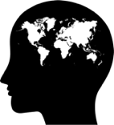
- Each community is unique with its own distinct needs and cultural experiences
- New technologies must be personable
- New technologies should support navigation of the existing medical and social service systems
- New technologies produced in partnership with communities should support communication between older Indigenous adults and their formal care providers as well as informal caregivers and natural helpers

Resources

For more information about Indigenous research and community-based participatory research partnerships, see the following resources:

Indigenous Cognition & Aging Awareness Research Exchange (I-CAARE)
https://www.i-caare.ca/

Memory Keepers Medical Discovery Team
https://memorykeepersmdt.com/

Indigenous Community-Based Health Research Lab: Morning Star Lodge
http://www.indigenoushealthlab.com/contact

References

Infographic reference.

Alzheimer-Society-of-Canada. Rising Tide: The Impact of Dementia on Canadian Society. Toronto: Alzheimer Society of Canada; 2010.

Christopher, S., Watts, V., McCormick, A. K. H. G., & Young, S. (2008). Building and Maintaining Trust in a Community-Based Participatory Research Partnership. American Journal of Public Health, 98(8), 1398-1406. doi:10.2105/ajph.2007.125757

Health-Canada. A statistical profile on the health of First Nations in Canada: self-rated health and selected conditions, 2002 to 2005. Ottawa: Health Canada; 2009.
Jacklin, K., Pace J. E., Warry, W. (2015). Informal dementia caregiving among Indigenous communities in Ontario, Canada. Care Management Journals. 16(2):106-20.
Jones, L., Jacklin, K., & O'Connell, M. E. (2017). Development and Use of Health-Related Technologies in Indigenous Communities: Critical Review. J Med Internet Res, 19(7), e256. doi:10.2196/jmir.7520

Maar, M. A., Yeates, K., Barron, M., Hua, D., Liu, P., Lum-Kwong, M. M., et al. I-RREACH: an engagement and assessment tool for improving implementation readiness of researchers, organizations and communiites in complex interventions. Implementation Science. 2015;10(64):13.
Marshall, M., Marshall, A., Bartlett, C. Chapter 2: Two-eyed seeing in medicine. In: Greenwood M, de Leeuw S, Lindsay NM, Reading C, editors. Determinants of Indigenous Peoples' Health in Canada: Beyond the Social. Toronto: Canadian Scholars' Press Inc.; 2015. p. 16-24.

Wilson, D. & Neville, S. (2009). Culturally safe research with vulnerable populations. Contemporary Nurse, 33(1), 69-79. DOI: 10.5172/conu.33.1.69

Center for Indigenous Research, S., and Technology (C-FIRST) at the Institute for Policy & Social Research,,. (n.d.). The Center for Indigenous Research, Science, and Technology studies the continually unfolding relationship between Indigenous peoples and their environment. Retrieved from http://ipsr.ku.edu/cfirst/
Indigenous Wellness Research Institute. (2020). Principles of Partnership. Retrieved from https://iwri.org/partnerships/principles-of-partnership/
Jacklin, K. (2019). ICAARE: Indigenous Cognition & Aging Awareness Research Exchange. Retrieved from https://www.i-caare.ca/
Lakehead University. (2020). Indigenous Research Resources. Retrieved from https://www.lakeheadu.ca/research-and-innovation/research-services/resources/indigenous
Laycock, A., Walker, D., Harrison, N., & Brands, J. (2011). Researching Indigenous health: A practical guide for researchers. Retrieved from Melbourne: https://www.lowitja.org.au/content/Document/PDF/Researchers-Guide_0.pdf
Maridulu Budyari Guma. (2020). Partnership: The key to powerful Aboriginal health research. Retrieved from https://www.thesphere.com.au/news/partnership-the-key-to-powerful-aboriginal-health-research
Memorial University. (2020). For researchers: Doing Indigenous research in a good way. Retrieved from https://www.mun.ca/research/Indigenous/faq.php
Montgomery, M. (2013). Fast Facts about Responsible Research Partnerships with Indigenous Communities. Retrieved from https://depts.washington.edu/ceeh/downloads/FF_Responsible.pdf

In our work we use the terms Elder and Traditional Knowledge Keeper to refer to individuals who are respected members of their community, who carry specific knowledge, teachings, and wisdom. We work closely with Elders and Traditional Knowledge Keepers, following traditional protocols, to ask for guidance and support throughout all our work.
Natural helpers are people who help older adults in their community, regardless of monetary compensation or familial relationship.

